***DSR系列（Series）***

**智能型数位式功率调整器**

**IntelligentDigital Power Regulator**

**使用说明书**

**Operating Instruction**

**NIETZ ELECTRIC CO., Ltd**

感谢您采用NIETZ DSR系列智能型数位式功率调整器，使用前务必详读本使用说明书以防止操作错误！

Thank you for choosing NIETZ DSR series intelligentdigital power regulator，Please read this operating instruction carefully before using it to avoid malfunction！

**操作注意事项/Caution When Operating**

● 断电后方可清洗仪表/Before cleaning the controller, please ensure that the power is switch off

● 清除显示器上污渍请用软布或棉纸/Please remove stains on the display panel by using a soft cloth only

● 显示器易被划伤，禁止用硬物擦拭或触及/No scrubbing or touching the display panel with any hard object, the display panel can be easily scratched

● 禁止用螺丝刀或书写笔等硬物体操作面板按键，否则会损坏或划伤按键/Do not press any button on the display panel using pointy objects such as ballpoint pen or screw driver, it can easily scratch the panel or damage buttons on the panel

**一、产品确认/Product validation**

DSR智能型数位式功率调整器是用先进的单片机技术设计而成的，是新一代的用可控硅控制正弦波波形导通大小从而达到控制交流电压输出大小的仪表，并具有以下特点/DSR Intelligent Digital Power Regulator is using advanced single-chip design, it is the new generation regulator providing control solution for power-conversion application by using SCR to control the sine wave：

■ **功能信息/The function of information**

● 电源频率50/60 Hz自动侦测 Power frequency 50/60 Hz auto-detect

● 可选择零点或相位控制方式 Zero cross control or phase angle control selectable

● 可设定最小或最大输出量限制 High and low output limit settable

● 可设定缓冲启动或脉冲启动时间 Soft start or kick start time settable

● 可选择多种输入方式 Multi-input type optional

● 可选择自动或手动输出 Auto output or manual output selectable

● 多种自动诊断警报功能 Multi automatic diagnostic alarm function

■ **产品选型/Product Selection**

●

|  |  |  |
| --- | --- | --- |
| Models | SCR-21-20 | SCR-23-20 |
| 工 作 电 压  Operating voltage | AC220V | AC380V |
| 额 定 电 流  Rated current | 20A  max. | 20A  max. |
| 保 险 丝  Protection fuse | 20A | 20A |
| 耐 突 波 电 流  Surge current duration | 400A | 400A |
| 最 低 耐 压  Min. block voltage | AC600V | AC800V |

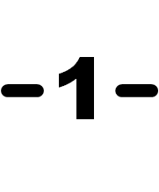

■ **共同规格/Specification**

|  |  |
| --- | --- |
| 输入方式 Input method | 4～20mA/0～20mA/1～5V/0～5V/2～10V/0～10V or VR-10KΩ selectable |
| 控制方式 Control method | Zero cross control or phase angle control selectable |
| 输出控制 Output control | Auto output or manual output selectable |
| 输出范围 Output range | 0～100％ |
| 输入解析度 Input resolution | 0.5％ |
| 输出下限 Output lower limit | 0～100％ (L.000～L.100) settable |
| 输出上限 Output upper limit | 0～199％ (H.000～H.199) settable |
| 缓冲启动 Soft start | 1～199s (t.001～t.199) settable |
| 保护功能 Protection function | Overcurrent (hardware overcurrent check), radiator overheating, fuse burnt |
| 使用环境 Operating temp | 86～106kPa、0～50℃、45～85％RH |
| 外壳材质 Housing material | ABS |

■ **适用范围信息/Scope of application**

● 本产品可与连续PID输出的温度控制仪表配合使用，达到高精度温度控制功能，也可单独用于高精度的电压控制等/This product can be used together with temperature controllers with Continuous PID output in order to achieve high accuracy of temperature control. It can also be used alone to achieve accurate voltage control

● 本产品可广泛应用于陶瓷、冶金、热处理、化工、电炉、窑炉等高精度温度控制，是传统的可控硅调压器的更新换代产品/This product can be used widely in high accuracy temperature control of ceramic, metallurgy, heat treatment, chemical engineering , electric stove and kilns etc, it is the new generation regulator replacement for the traditional SCR regulators

● 请参照上述定制信息确认送达产品是否和您选定的型号和功能完全一致/Please check carefully with the information provided above to confirm the product delivered to you is the same model and function you order

1. **接线图和外形尺寸图/Connection diagram and outline dimension**

**1、接线图/Connection diagram**

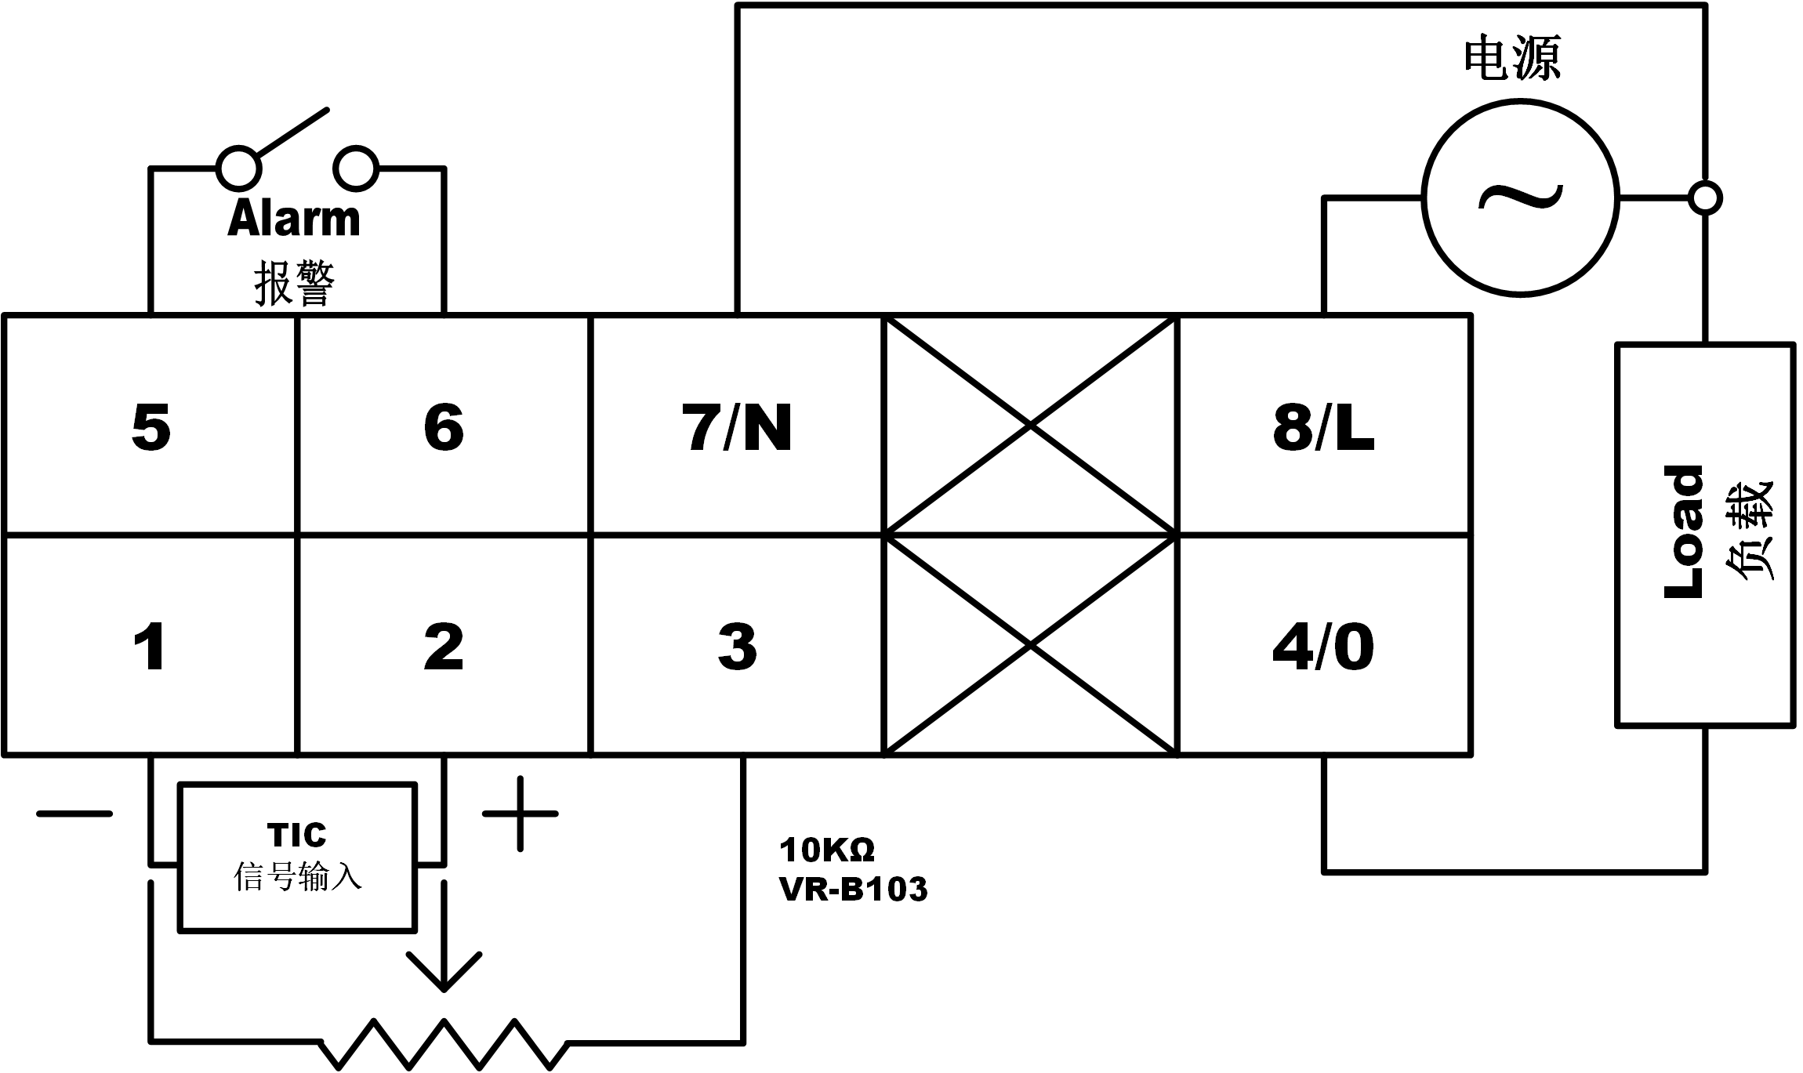

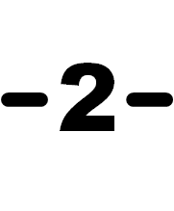

**2、外形尺寸图/Outline dimension**

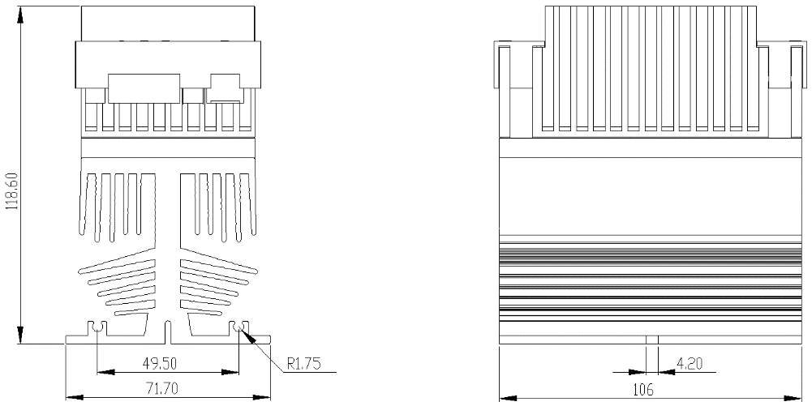

1. **菜单设定/Menu setting**
2. **功能设定/Function setting**

|  |  |  |
| --- | --- | --- |
| **状态/Status** | **显示代码/Display code** | **说明/Description** |
|  |  | 1、A:自动输出量/Auto output volume  2、M:手动输出量/Manual output volume |
| 1、Lck.0:全锁定/All lock  2、Lck.1:仅参数可设定/Only data settable  3、Lck.2:可设定/Unlock |
| 1、Out.A:自动输出量/Auto output volume  2、Out.M:手动输出量/Manual output volume |
| 1、Int.0: 4～20mA 2、Int.1: 0～20mA  3、Int.2: 1～5V 4、Int.3: 0～5V  5、Int.4: 2～10V 6、Int.5: 0～10V  7、Int.6: 10KΩ可变电位器/10KΩ Variable resistance |
| 1、Con.0:零点控制/Zero cross control  2、Con.1:相位控制/Phase control |
| 1、Str.0:缓冲启动/Soft start  2、Str.1:脉冲启动/Kick start |
| 1、Alm.0:报警输出常开/Alarm output normal open(NO)  2、Alm.1:报警输出常闭/Alarm output normal close(NC) |

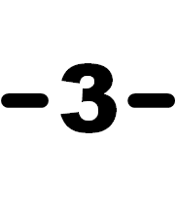

**2、参数设定/Data setting**

|  |  |  |
| --- | --- | --- |
| **状态/Status** | **显示代码/Display code** | **说明/Description** |
|  |  | 1、A:自动输出量/Auto output volume  2、M:手动输出量/Manual output volume |
| 1、范围/Range:0～100  2、最小输出量设定/Minimum output volume setting |
| 1、范围/Range:0～199  2、最大输出量设定/Maximum output volume setting |
| 1、范围/Range:0～50  2、可控硅小输出切除/TRIACS small output  resection |
| 1、范围/Range:1～199  2、缓冲启动时间/Time of soft start 或/or  脉冲启动时间/Time of kick start |
| 1、范围/Range:-99～99  2、输入偏差修正/Setting of Input offset |

**3、手动输出设定/Setting of manual output**

|  |  |
| --- | --- |
| **手动输出状态/Manual output status** | **说明/Description** |
|  | 1、在手动输出状态中，按 △ 或 ▽ 键1秒可改变手动输出量/On the  manual output status,Press △ or ▽ key one second to change the manual output vomlune  2、按 SET 键完成手动输出量设定/Press SET to finish setting |

1. **菜单参数详解/** **Menu parameter details**

**1、启动方式说明/Start mode description**

**缓冲启动/Soft start** **脉冲启动/Kick start** **说明/Description**



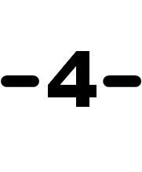

**2、控制方式说明/Illustration of control method**

|  |  |  |  |
| --- | --- | --- | --- |
| **控制方法/Control method** | | **相位控制/Phase angle control** | **零点控制/Zero cross control** |
| **输 出 量**  **/Output volume** | **10％** |  |  |
| **25％** |  |  |
| **50％** |  |  |
| **75％** |  |  |
| **特性/Feature** | | 1、适用于控制电感性或变阻性负载  例如：红外线加热器、变压器负载、纯金属或碳硅发热体/Suited to control the inductive load or The variable resistance load  For example:IR、Pure metal heater、 Silicone carbonate heater or Transformer  2、功率因素小于1/The power factor  cosΘ ＜ 1  3、较高谐波干扰/Higher harmonic noise | 1、适用于控制定阻性负载或电容性负载  例如：合金类发热体或电容器负载/  Suited to control the constant resistance load or The capacity load  For example:Alloy heater or Capacitor  2、功率因素等于1/The power factor  CosΘ ＝ 1  3、较低谐波干扰/Lower harmonic noise |

**3、输出量限制设定/Output limit Setting**

**注意/Note：**

1、Un：输出量/Output volume

2、设定范围/Setting range：下限设定/Low limit = 0～100％，上限设定/High limit = 0～199％

3、输出量下限 + 上限设定适用于高辐射热加热器，如：红外线加热器/Low + high limit setting is suited to control the radial heating heater，such as：IR lamp

**五、故障排除/Trouble shooting**

|  |  |  |
| --- | --- | --- |
| **报警/Alarm** | **说明/Description** | **检查/Checking** |
| FBEr | 保险丝烧毁/Fuse break | 请检查保险丝是否烧毁/Please check power supply |
| OHEr | 散热器过热超过120℃/Over heat 120℃ | 请改善散热条件/Please improve cooling condition |



**六、安全注意事项/Safety notice**

|  |  |
| --- | --- |
| **警 告**  **Warning** | **潜在危险，如果操作失当可能导致死亡或严重伤害**  **Potentially hazardous situation, if mishandling, may result in death or serious injury** |
| 1、请确认「输入方式」与本控制器「输入选择」是否相符？接线是否正确？否则可能导致本控制器失控  Please confirm the input type and connection method with this controller, if not, it may result in malfunction  2、带电运行中，请勿触碰本控制器任何接线端子以避免触电  Please do not touch any terminal of this controller while power supply is supplied,if do, it may result in electronic shock  3、更换保险丝前，请务必关闭电源系统以避免触电  「Power supply system」must to be shut down before replace the fuse,if not,it may result in electronic shock  4、负载电流请勿超过额定电流，以避免保险丝或本控制器烧毁  Please rated the load current within the specified value,if not,it may result to burn up this controller or fuse  5、请务必锁紧端子螺丝，扭力需超过100kg-cm，否则可能导致本控制器或保险丝烧毁  Please tighten the screw terminal over 100kg-cm,if not,it may result to burn up this controller or fuse  6、本控制器烧毁后可能是短路或失控状态，请加装独立警报系统以确保安全，否则可能造成严重意外事故  If this controller is burned up,it may be in short circuit condition or malfunction,please settle an independent alarm system to ensure safety protection,if not,it may result in a serious accident | |

**七、安装注意事项及可控硅小知识/Installation and SCR tips**

■ **安装注意事项/Caution when installing**

● 仪表应在推荐的工作环境下使用

The installation and usage of the equipment should be done under the suggested working conditions

● 模拟量输入值不要超过仪表的输入信号范围

Analogy input could not exceed the input signal range of the regulator

● 严谨猛力撞击仪表

Do not expose the regulator to any vibration or shock directly

● 电源电压不要超过工作电压±10%范围

Power supply could not exceed 10% of the working voltage

■ **可控硅小知识/SCR tips**

● 断态、反向重复峰值电压：一般取负载电压有效值的三倍以上，例如：AC220V供电的负载，可控硅

的峰值电压应大于AC800V；AC380V供电的负载，可控硅的峰值电压应大于AC1200V

Peak repetitive off state voltage and peak repetitive reverse voltage: Normally use a value more than three times of the effective value of the load voltage, for example: for load voltage with AC220V, SCR peak voltage should be more than AC800V; for lad voltage with AC380V, SCR peak voltage should be more than AC1200V

● 门极触发电流：一般选择60～150mA之间，门极触发电流太小，容易引起可控硅误触发；门极触发电流太大，容易引起可控硅输出小电流时出现打不开现象

Gate trigger current: Normally choose between 60～150mA. If the gate trigger current is under the value, the SCR can be mis-triggered easily. If the gate trigger current is over the value, SCR output current can not be opened

● 门极触发电压：一般应小于2V

Gate trigger voltage: < 2V

● 通态峰值电压：通态峰值电压越小越好，通态峰值电压越小则发热量越低即可控硅损耗越小

Peak forward on-state voltage: the lower the peak forward on-state voltage value the better as lower value of the peak forward on-state voltage means less heat and less loss

**八、维护和保存/Service and maintenance**

● 产品自开票之日起十八个月内，因制造质量发生故障由本厂负责全面保修，因使用不当而造成损坏

的则本厂酌情收取修理成本费，本厂仪表终身维修

This equipment is under warranty for 18 months since the day of purchase (the warranty only stands if the problem is caused by the malfunction due to manufacturing). Any repairment for damages caused by improper use of the equipment will be charged. The equipment is provided with lifetime maintenance and repair on cost

● 仪表应在包装齐全的情况下存放在干燥通风、无腐蚀性气体的场合

Please keep the controller in a dry place with air and NO corrosive gas